Termwork – 1 : Linux Internal and External Commands

Termwork – 2A : FCFS Scheduling Algorithm

/*

FCFS Scheduling Program in C

*/

#include <stdio.h>

#include <stdlib.h>

int main()

{

int pid[15];

int bt[15];

int n;

printf("Enter the number of processes : ");

scanf("%d",&n);

printf("Enter process id of all processes : ");

for(int i=0;i<n;i++){

scanf("%d",&pid[i]);

}

printf("Enter burst time of all the processes : ");

for(int i=0;i<n;i++){

scanf("%d",&bt[i]);

}

int wt[n];

wt[0]=0;

//calculating waiting time of each process

for(int i=1;i<n;i++){

wt[i]=bt[i-1]+wt[i-1];

}

printf("Process ID Burst Time Waiting Time Turnaround Time\n");

float twt=0.0;

float ttt=0.0;

for(int i=0;i<n;i++){

printf("%d\t\t",pid[i]);

printf("%d\t\t",bt[i]);

printf("%d\t\t",wt[i]);

//calculating and printing turnaround time for each process

printf("%d\t\t",bt[i]+wt[i]);

printf("\n");

//total waiting time

twt+=wt[i];

//total turnaround time

ttt=wt[i]+bt[i];

}

//avg wating time

float awt=twt/n;

//avg turnaround time

float att=ttt/n;

printf("Avg. waiting time = %f\n",awt);

printf("Avg. turnaround time = %f\n",att);

return 0;

}

Termwork – 2B : SJF Scheduling Algorithm

/*

SJF Scheduling Program in C

*/

#include <stdio.h>

#include <stdlib.h>

int main()

{

int bt[20],p[20],wt[20],tat[20],i,j,n,total=0,totalT=0,temp;

float avg_wt,avg_tat;

printf("Enter the number of processes : ");

scanf("%d",&n);

printf("\nEnter Burst Time:\n");

for(i=0;i<n;i++){

printf("p%d : ",i+1);

scanf("%d",&bt[i]);

p[i]=i+1;

}

for(i=0;i<n;i++){

for(j=0;j<n-i-1;j++){

if(bt[j]>bt[j+1]){

temp=bt[j];

bt[j]=bt[j+1];

bt[j+1]=temp;

temp=p[j];

p[j]=p[j+1];

p[j+1]=temp;

}

}

}

wt[0]=0;

tat[0]=bt[0];

//Waiting time and turnaround time

for(i=1;i<n;i++){

wt[i]=0;

wt[i]=bt[i-1]+wt[i-1];

tat[i]=bt[i]+wt[i];

}

printf("Process ID Burst Time Waiting Time Turnaround Time\n");

for(int i=0;i<n;i++){

printf("%d\t\t",p[i]);

printf("%d\t\t",bt[i]);

printf("%d\t\t",wt[i]);

printf("%d\t\t",tat[i]);

printf("\n");

total+=wt[i];

totalT+=tat[i];

}

//avg wating time

avg_wt=(float)total/n;

//avg turnaround time

avg_tat=(float)totalT/n;

printf("Avg. waiting time = %f\n",avg_wt);

printf("Avg. turnaround time = %f\n",avg_tat);

return 0;

}

Termwork – 3 : Unix Process control system calls Date : 03/03/2025

#include<stdio.h>

#include<stdlib.h>

#include<unistd.h>

#include<sys/types.h>

#include<sys/wait.h>

int main()

{

pid_t pid;

pid=fork();//Create a child process

if(pid<0){

perror("Fork failed");

exit(1);

} else if(pid==0){//child process

printf("Child Process : PID = %d, Parent PID = %d\n",getpid(),getppid());

sleep(2);//Simulate some work

printf("Child Process exiting\n");

exit(0);

} else{

printf("Parent Process : PID = %d, Child PID = %d\n",getpid(),pid);

int status;

wait(&status);//Wait for child process to complete

printf("Parent Process :Child exited with status %d\n",WEXITSTATUS(status));

}

return 0;

}

Termwork – 4 : Process Synchronization - The Dining-Philosophers Problem

Date : 03/03/2025

#include <stdio.h>

#include <stdlib.h>

#include <time.h>

#include <pthread.h>

#include <unistd.h>

pthread_t* philosophers;

pthread_mutex_t* forks;

int philosophers_count;

pthread_barrier_t barrier; // Barrier to synchronize the start of all philosophers

void eat(int i) {

printf("Philosopher %d is eating\n", i + 1);

sleep(1 + rand() % 10);

}

void* philosopher(void* args) {

int i = *((int*)args); // Get philosopher's index directly from arguments

int first, second;

// Synchronize all philosophers to start together

pthread_barrier_wait(&barrier); // Wait for all philosophers to be ready

while (1) {

printf("Philosopher %d is thinking\n", i + 1);

sleep(1 + rand() % 10);

first = i;

second = (i + 1) % philosophers_count;

// Lock forks in a consistent order (lower numbered fork first)

if (first > second) {

first = second;

second = i;

}

pthread_mutex_lock(&forks[first]);

pthread_mutex_lock(&forks[second]);

eat(i);

pthread_mutex_unlock(&forks[first]);

pthread_mutex_unlock(&forks[second]);

}

return NULL;

}

int main() {

int i, err;

srand(time(NULL)); // Seed the random number generator

printf("Enter the number of philosophers: ");

scanf("%d", &philosophers_count);

philosophers = (pthread_t*)malloc(philosophers_count * sizeof(pthread_t));

forks = (pthread_mutex_t*)malloc(philosophers_count * sizeof(pthread_mutex_t));

// Initialize mutexes for each fork

for (i = 0; i < philosophers_count; ++i) {

if (pthread_mutex_init(&forks[i], NULL) != 0) {

printf("Failed initializing fork %d\n", i + 1);

return 1;

}

}

// Initialize the barrier to synchronize the start of all threads

if (pthread_barrier_init(&barrier, NULL, philosophers_count) != 0) {

printf("Error initializing barrier\n");

return 1;

}

// Create threads for each philosopher

for (i = 0; i < philosophers_count; ++i) {

int* index = (int*)malloc(sizeof(int));

*index = i;

err = pthread_create(&philosophers[i], NULL, philosopher, (void*)index);

if (err != 0) {

printf("Error creating philosopher %d: %s\n", i + 1, strerror(err));

// Clean up already created threads and mutexes before exiting

for (int j = 0; j < i; ++j) {

pthread_cancel(philosophers[j]);

pthread_join(philosophers[j], NULL);

}

for (int j = 0; j < i; ++j) {

pthread_mutex_destroy(&forks[j]);

}

return 1;

} else {

printf("Successfully created philosopher %d\n", i + 1);

}

}

// Join all threads

for (i = 0; i < philosophers_count; ++i) {

pthread_join(philosophers[i], NULL);

}

// Clean up allocated memory and destroy mutexes

for (i = 0; i < philosophers_count; ++i) {

pthread_mutex_destroy(&forks[i]);

}

free(philosophers);

free(forks);

// Destroy the barrier

pthread_barrier_destroy(&barrier);

return 0;

}

Termwork – 5A : Process Synchronization-Reader- writer and Producer –consumer Problem

Date : 10/03/2025

#include<stdio.h>

#include<semaphore.h>

#include<unistd.h>

#include<pthread.h>

sem_t rw_mutex; // Controls access to the shared resource

sem_t mutex; // Controls access to reader_count

int reader_count = 0; // Number of active readers

int shared_data = 0; // Shared resource

void* reader(void* arg) {

int reader_id = *((int*)arg);

while (1) {

sem_wait(&mutex);

reader_count++;

if (reader_count == 1) {

sem_wait(&rw_mutex); // First reader locks the resource

}

sem_post(&mutex);

// Critical Section (Reading)

printf("Reader %d: Read shared data = %d\n", reader_id, shared_data);

usleep(500000); // Simulating reading time

sem_wait(&mutex);

reader_count--;

if (reader_count == 0) {

sem_post(&rw_mutex); // Last reader unlocks the resource

}

sem_post(&mutex);

usleep(500000);

}

return NULL;

}

void* writer(void* arg) {

int writer_id = *((int*)arg);

while (1) {

sem_wait(&rw_mutex); // Locks the resource exclusively

// Critical Section (Writing)

shared_data++; // Modify shared resource

printf("Writer %d: Wrote shared data = %d\n", writer_id, shared_data);

usleep(500000); // Simulate writing time

sem_post(&rw_mutex); // Release the resource

usleep(500000);

}

return NULL;

}

int main() {

pthread_t r_threads[5], w_threads[2];

int reader_ids[5] = {1, 2, 3, 4, 5};

int writer_ids[2] = {1, 2}; // Corrected initialization of writer_ids

sem_init(&rw_mutex, 0, 1); // Initialize rw_mutex for exclusive access

sem_init(&mutex, 0, 1); // Initialize mutex for controlling reader_count

// Create reader and writer threads

for (int i = 0; i < 5; i++) {

pthread_create(&r_threads[i], NULL, reader, &reader_ids[i]);

}

for (int i = 0; i < 2; i++) {

pthread_create(&w_threads[i], NULL, writer, &writer_ids[i]);

}

// Join all threads (in practice, this won't be reachable due to infinite loops)

for (int i = 0; i < 5; i++) {

pthread_join(r_threads[i], NULL);

}

for (int i = 0; i < 2; i++) {

pthread_join(w_threads[i], NULL);

}

sem_destroy(&rw_mutex);

sem_destroy(&mutex);

return 0;

}

Termwork – 5B : Process Synchronization Producer –consumer Problem

Date : 10/03/2025

#include<stdio.h>

#include<stdlib.h>

#include<semaphore.h>

#include<unistd.h>

#include<pthread.h>

#define BUFFER_SIZE 5 // Size of the buffer

int buffer[BUFFER_SIZE];

int in = 0, out = 0; // Indexes for producer and consumer

sem_t empty, full; // Semaphores for synchronization

pthread_mutex_t mutex; // Mutex for critical section

// Producer function

void* producer(void* arg) {

int item = 1;

while (1) {

sleep(1); // Simulating production time

sem_wait(&empty); // Wait if buffer is full

pthread_mutex_lock(&mutex); // Lock critical section

// Produce an item

buffer[in] = item;

printf("Producer produced: %d\n", item);

in = (in + 1) % BUFFER_SIZE;

item++;

pthread_mutex_unlock(&mutex); // Unlock critical section

sem_post(&full); // Signal that buffer is not empty

}

}

// Consumer function

void* consumer(void* arg) {

while (1) {

sleep(2); // Simulating consumption time

sem_wait(&full); // Wait if buffer is empty

pthread_mutex_lock(&mutex); // Lock critical section

// Consume an item

int item = buffer[out];

printf("Consumer consumed: %d\n", item);

out = (out + 1) % BUFFER_SIZE;

pthread_mutex_unlock(&mutex); // Unlock critical section

sem_post(&empty); // Signal that buffer has space

}

}

int main() {

pthread_t prod, cons;

// Initialize semaphores and mutex

sem_init(&empty, 0, BUFFER_SIZE);

sem_init(&full, 0, 0);

pthread_mutex_init(&mutex, NULL);

// Create producer and consumer threads

pthread_create(&prod, NULL, producer, NULL);

pthread_create(&cons, NULL, consumer, NULL);

// Join threads

pthread_join(prod, NULL);

pthread_join(cons, NULL);

// Destroy semaphores and Mutex

sem_destroy(&empty);

sem_destroy(&full);

pthread_mutex_destroy(&mutex);

return 0;

}

Termwork – 6 : Deadlock – Banker’s algorithm

Date : 24/03/2025

//Modified Bankers Algorithm

#include <stdio.h>

void main()

{

int process,resource,i,j,instance,k=0,count=0,m=0,h=0,outer,p,l;

printf("\nEnter the number of processes : ");

scanf("%d",&process);

l=process;

printf("\nEnter the number of resources : ");

scanf("%d",&resource);

int avail[resource],max[process][resource],allot[process][resource],need[process][resource],completed[process],pending[10];

for(i=0;i<process;i++){

completed[i]=0;

pending[i]=i;

}

printf("\nEnter number of Available Instances : ");

for(i=0;i<resource;i++){

scanf("%d",&avail[i]);

}

printf("\nEnter maximum number of instances resources that a process needs : \n");

for(i=0;i<process;i++){

printf("For p[%d] ",i);

for(j=0;j<resource;j++){

scanf("%d",&max[i][j]);

}

}

printf("\nEnter number of instances already allocated to the process of a resource : \n");

for(i=0;i<process;i++){

printf("For p[%d] ",i);

for(j=0;j<resource;j++){

scanf("%d",&allot[i][j]);

need[i][j]=max[i][j]-allot[i][j];

}

}

for(outer=process;outer>=0;outer--){

for(j=0;j<l;j++){

i=pending[j];

if(completed[j]!=1){

k=0;

for(m=0;m<resource;m++){

if(need[i][m]<=avail[m]){

k++;

}

}

if(k==resource && completed[j]==0){

printf("p[%d]\t",i);

completed[j]=1;

for(p=0;p<resource;p++){

avail[p]=avail[p]+allot[j][p];

}

count++;

}

}

}

}

if(count==process){

printf("\nSafe Sequence exists\n");

}else{

printf("Not exists\n");

}

}

Termwork – 7 : Memory Management - Page replacement

Date : 10/03/2025

#include <stdio.h>

#define MAX_FRAMES 3 //number of page frames

#define MAX_PAGES 10 //number of pages

//fun to check if a page is already in memory

int is_page_in_frames(int frames[],int num_frames,int page){

for(int i=0;i<num_frames;i++){

if(frames[i]==page)

return 1;//page found in frames

}

return 0;//page not found

}

//FIFO page replacement algorithm

void fifo_page_replacement(int pages[],int num_pages,int num_frames){

int frames[MAX_FRAMES];//page frames

int front=0;//points to the oldest page in queue

int page_faults=0;//page fault counter

//initialize frames to -1(empty)

for(int i=0;i<num_frames;i++){

frames[i]=-1;

}

printf("\nPage reference string : ");

for(int i=0;i<num_pages;i++)

printf("%d ",pages[i]);

printf("\n\n");

//process each request

for(int i=0;i<num_pages;i++){

int page=pages[i];

//check if the page is already in memory

if(!is_page_in_frames(frames,num_frames,page)){

//page fault occurs, replace the oldest page

frames[front]=page;

front = (front+1)%num_frames;//move pointer to the next page

page_faults++;

//print the frame content

printf("Page %d is loaded : ",page);

for(int j=0;j<num_frames;j++){

if(frames[j]!=-1)

printf("%d ",frames[j]);

else

printf("-");

}

printf("\n");

}

else{

printf("Page %d already in frames. No replacement needed.\n",page);

}

}

printf("\nTotal Page Faults : %d\n",page_faults);

}

int main()

{

int pages[MAX_PAGES]={1,3,0,3,5,6,3,5,1,3};//Example reference string

int num_pages=10;

int num_frames=MAX_FRAMES;

fifo_page_replacement(pages,num_pages,num_frames);

return 0;

}

Termwork – 8 : File allocation strategies

Date : 10/03/2025

#include <stdio.h>

#include <stdlib.h>

#define MAX_BLOCKS 100

//block status : 0=free, 1=allocated

int disk[MAX_BLOCKS] = {0};

//Function to allocate file using sequential allocation

void sequential_allocation(int start,int length){

if(start + length > MAX_BLOCKS){

printf("Error: Not enough contiguous state!\n");

return;

}

//check if blocks are free

for(int i=start;i<start+length;i++){

if(disk[i]==1){

printf("Error : Block %d is already allocated!\n",i);

return;

}

}

//Allocated blocks

for(int i=start;i<start+length;i++){

disk[i]=1;

}

printf("File allocated using Sequential Allocation from Block %d to %d\n",start,start+length-1);

}

//Node structure for linked allocation

typedef struct Node{

int block;

struct Node* next;

}Node;

//fun to allocate file using linked allocation

void linked_allocation(int blocks[],int length){

Node* head=NULL;

Node* temp=NULL;

//Allocated blocks

for(int i=0;i<length;i++){

if(disk[blocks[i]]==1){

printf("Error : Block %d is already allocated!\n",blocks[i]);

return;

}

disk[blocks[i]]=1;

//create new node

Node* newNode = (Node*)malloc(sizeof(Node));

newNode->block = blocks[i];

newNode->next = NULL;

if(head==NULL){

head=newNode;

temp=newNode;

}else{

temp->next = newNode;

temp=newNode;

}

}

//print allocation

printf("File allocated using Linked Allocation at blocks : ");

temp=head;

while(temp!=NULL){

printf("%d -> ",temp->block);

temp=temp->next;

}

printf("NULL\n");

//Free allocated list

while(head!=NULL){

temp=head;

head=head->next;

free(temp);

}

}

int main()

{

int ch,start,length,num_blocks,blocks[MAX_BLOCKS];

while(1){

printf("\nFile Allocation Methods : \n");

printf("1. Sequential Allocation\n");

printf("2. Linked Allocation\n");

printf("3. Exit\n");

printf("Enter choice : ");

scanf("%d",&ch);

switch(ch){

case 1:

printf("Enter start block and length : ");

scanf("%d %d",&start,&length);

sequential_allocation(start,length);

break;

case 2:

printf("Enter number of blocks : ");

scanf("%d",&num_blocks);

printf("Enter block numbers : ");

for(int i=0;i<num_blocks;i++)

scanf("%d",&blocks[i]);

linked_allocation(blocks,num_blocks);

break;

case 3:

printf("\nExiting......\n");

exit(0);

default:

printf("Invalid choice\n");

}

}

return 0;

}

Termwork – 9 : pwd, cd, mkdir, rmdir, cp, rm, mv, cat ; Unix shell scripts

Date : 10/03/2025

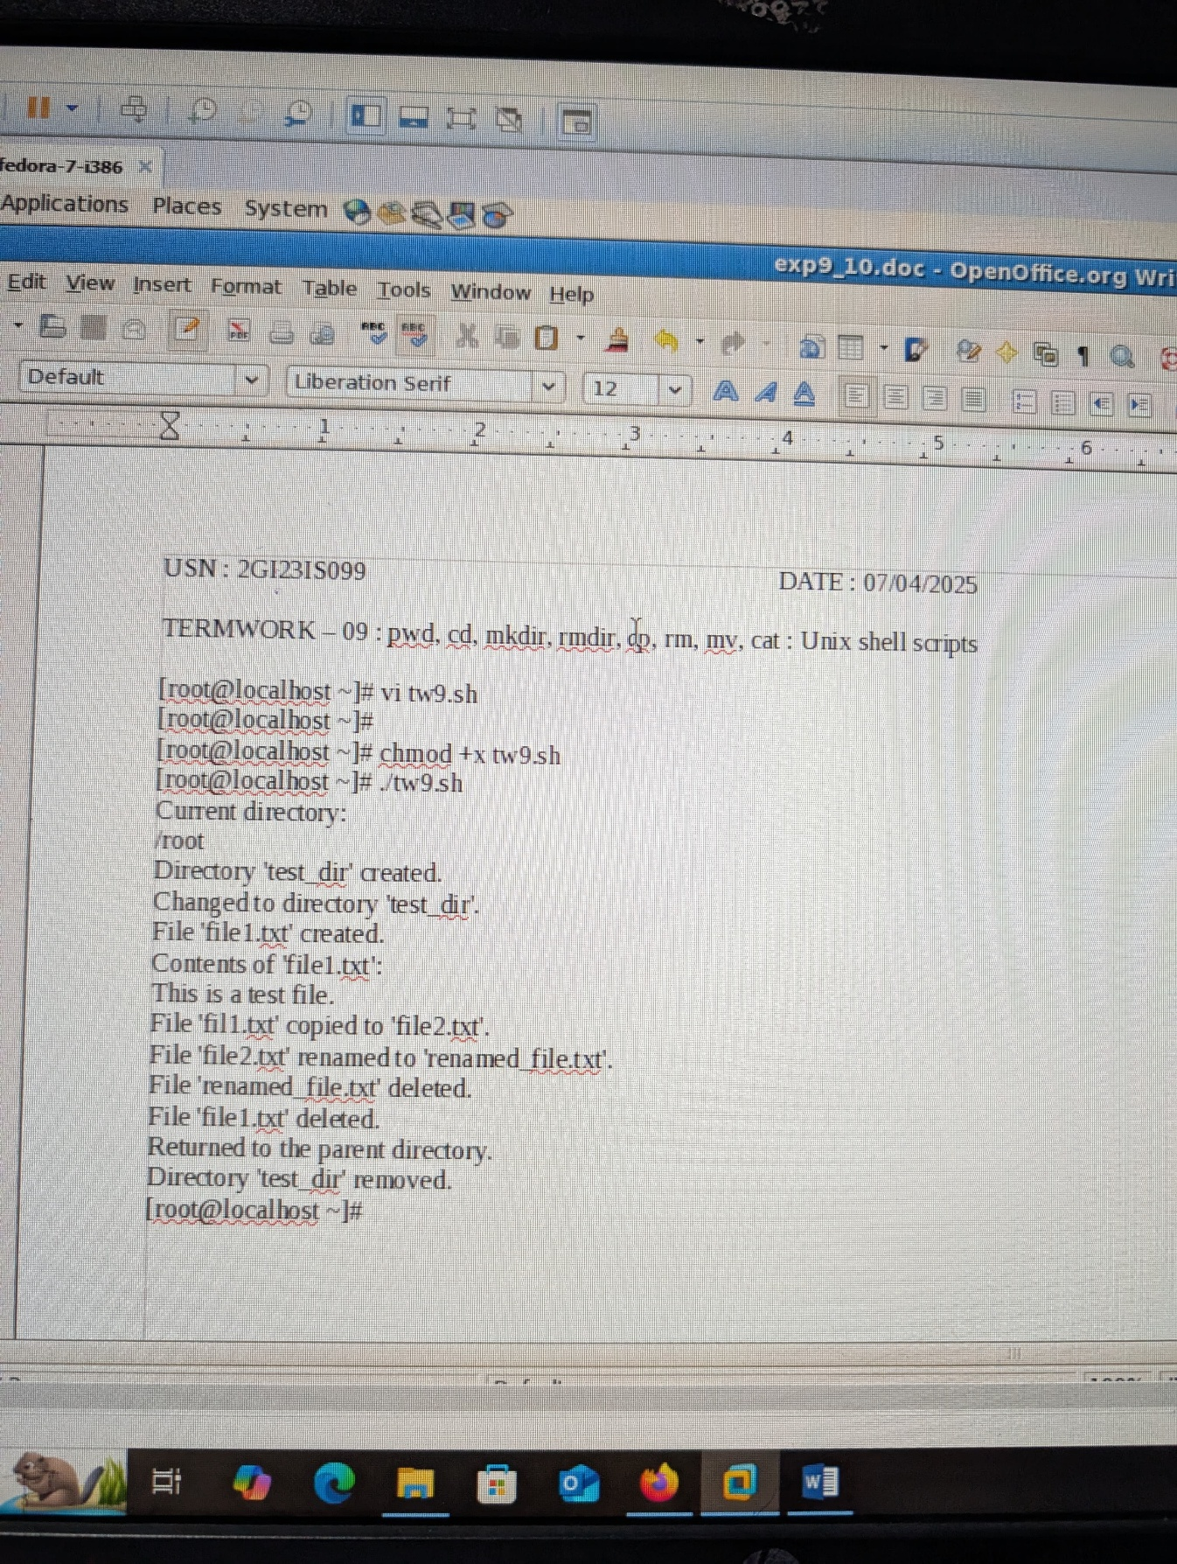

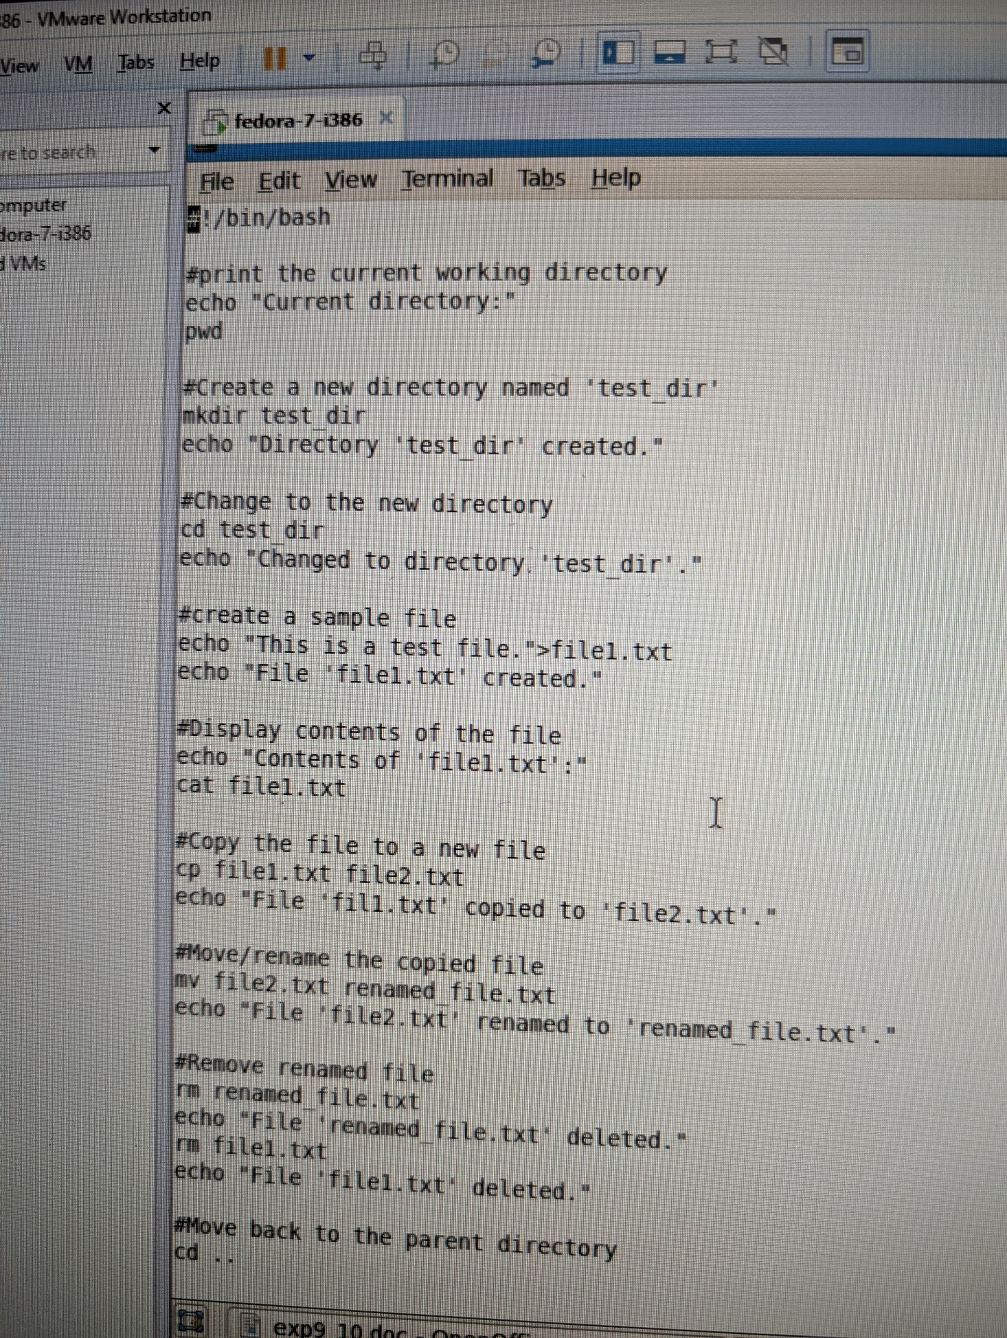

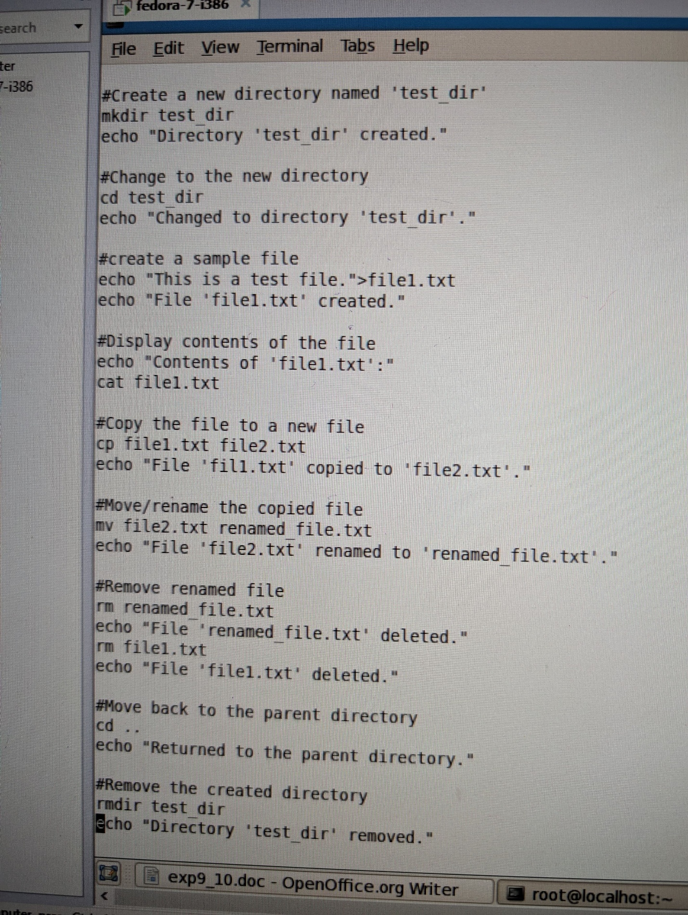

Termwork – 10 : File Attributes: ls, ls-l, ls-d, file permissions, chmod Unix shell scripts

Date : 10/03/2025

